**City University**

Programming Club

Test: C Programming Language (Basic)

Total marks: 20 Duration: 40 minutes

1. 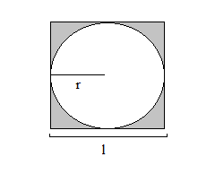Find the area of the gray part:
2. Find the summation of the series: 5 + 15 + 25 + 35 + ……………….. + n

**City University**

Programming Club

Test: C Programming Language (Basic)

Total marks: 20 Duration: 40 minutes

1. Find the area of the gray part:
2. Find the summation of the series: 5 + 15 + 25 + 35 + ……………….. + n

**City University**

Programming Club

Test: C Programming Language (Basic)

Total marks: 20 Duration: 40 minutes

1. Find the area of the gray part:
2. Find the summation of the series: 5 + 15 + 25 + 35 + ……………….. + n